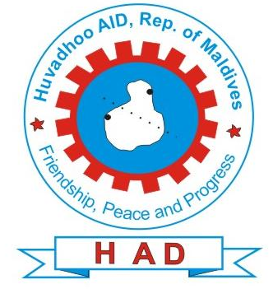
Huvadhoo Aid

Republic of Maldives

PP size photo

Volunteer Application Form

www.huvadhooaid.org

Personal Details
Name: (first, middle, last)
Gender: | D.O.B: | Nationality:

Address:
City: | State/County: | Zip/Postal code:
Home Phone: | Office Phone: | Cell/Pager:
Fax Number: | Email:
Profession:
Speciality:

Education

Highest Qualification

Other Relevant Qualifications and Skills

Experience
Please list all prior international experience.
 | Country | Date | Post
1.
2.

Availability
The amount of time I can volunteer would be (select largest possible number):
__2 weeks | __1 month | __3 months | __6 months | __9 months | __ 12 months | __Other ________________

Date Preferred

Alternate Dates

Companions
I wish to be accompanied by:
Spouse (list name)
Children (list names and ages)
Other (list name)
N/A
Would your companion* be interested in serving in a volunteer capacity?
If yes, in what capacity?
*Your companion will be expected to join HAD and may need to complete a Volunteer Profile Form.

Preferred living arrangements (Group living, single room, home-stay, double room, no preference). Please specify ……………………………………………………………………..
Could you share room with other volunteers? ……………………………………………
How did you hear about the Huvadhoo Aid Volunteer Program?

Emergency Contact
Please list name of person to be notified in case of an emergency.
Name (first middle last)

Address
City | State | Zipcode
Office Phone | Home Phone | Email

Please list your top 3 placement choices (minimum of 1)

1…………………………………

2…………………………………

3…………………………………

Send completed form to:

admin@huvadhooaid.org, or imad@huvadhooaid.org

Huvadhoo Aid
Gaaf Dhaal Hoadedhdhoo
Republic of Maldives
Phone: (960) 7662474

Fax: (960)7799706
Email: admin@huvadhooaid.org

